Lab2
bash-script

1.Create a script that asks for user name then send a greeting to him.





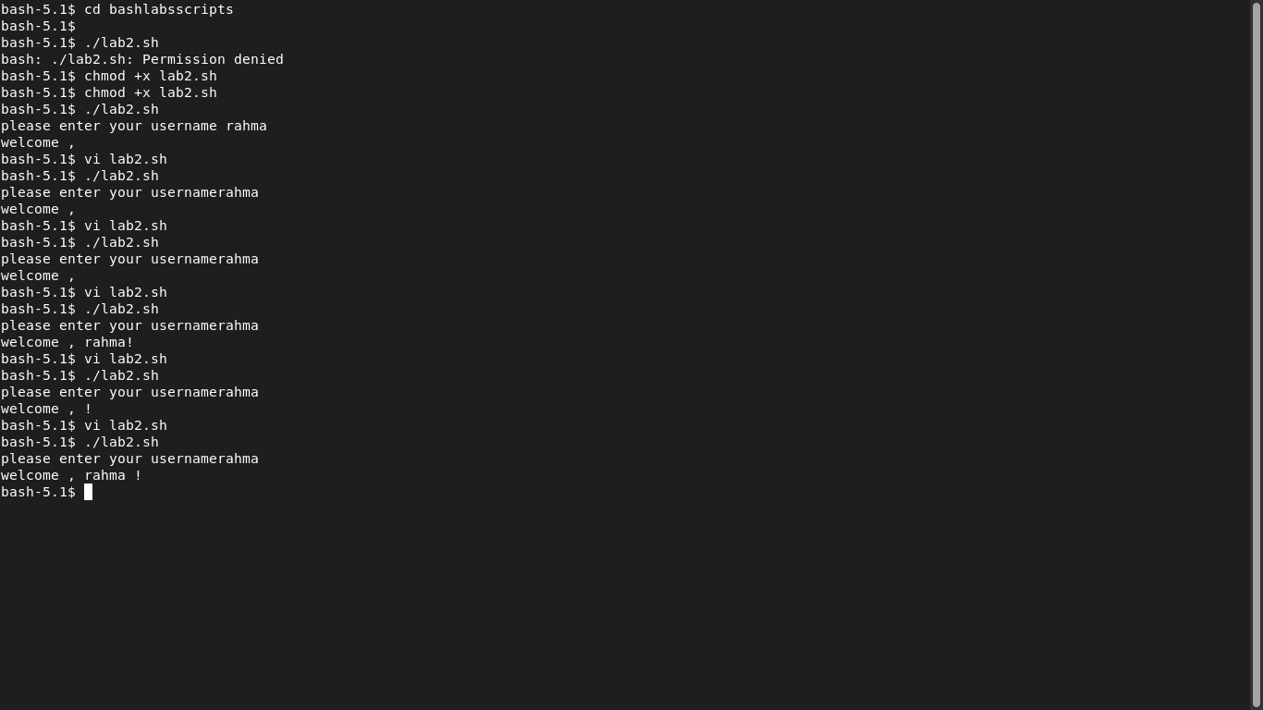

2.Create a script called s1 that calls another script s2 where:

a.In s1 there is a variable called x, it's value 5



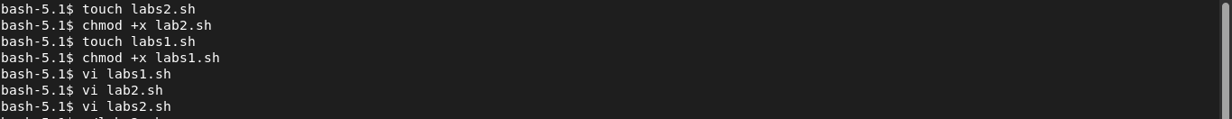



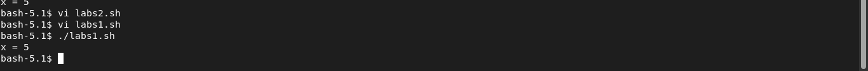
b.Try to print the value of x in s2 by two different ways.



3.Create a script called mycp where:

a.It copies a file to another
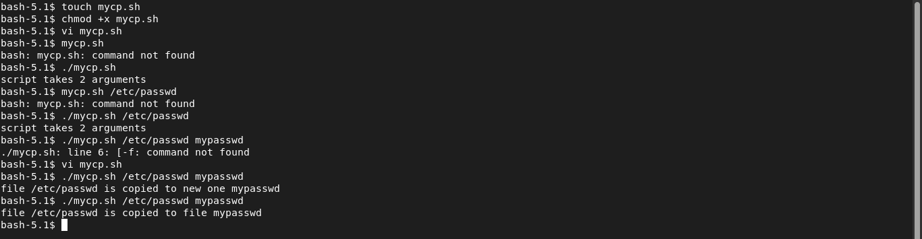
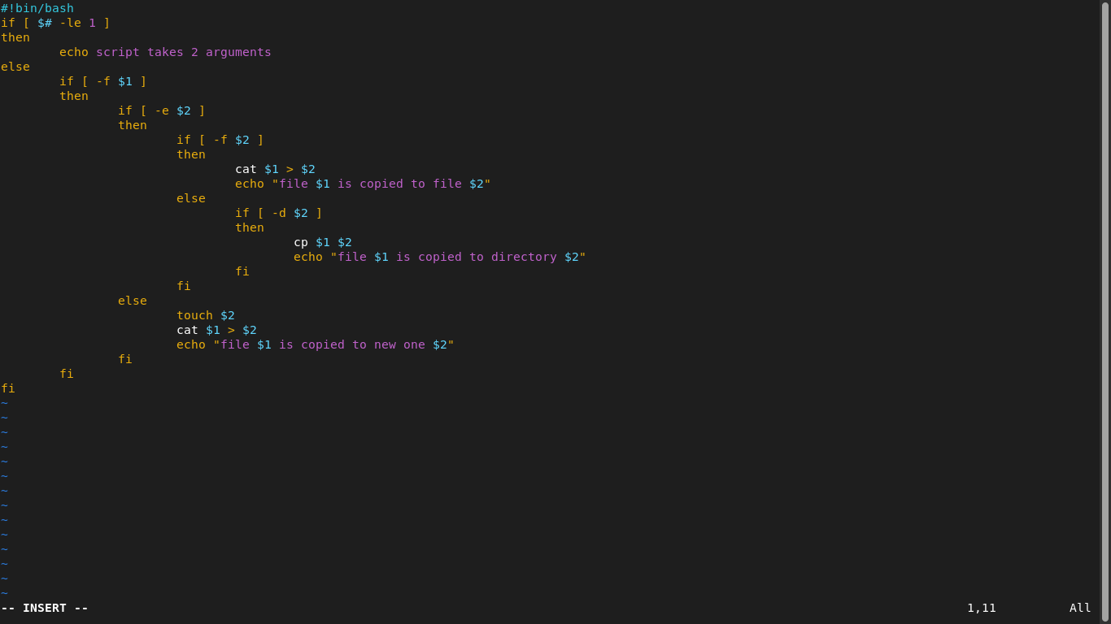

b.It copies multiple files to a directory.


4.Create a script called mycd where:

a.It changed directory to the user home directory, if it is called without arguments.

b.Otherwise, it change directory to the given directory.

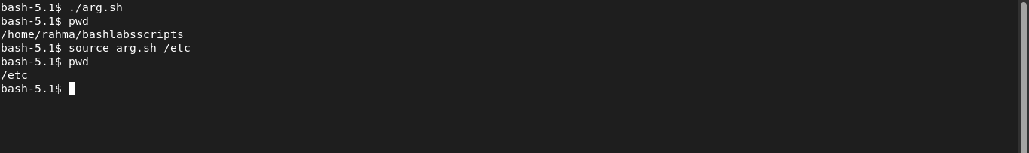


5.Create a script called myls where:

a.It lists the current directory, if it is called without arguments.

b.Otherwise, it lists the given directory.

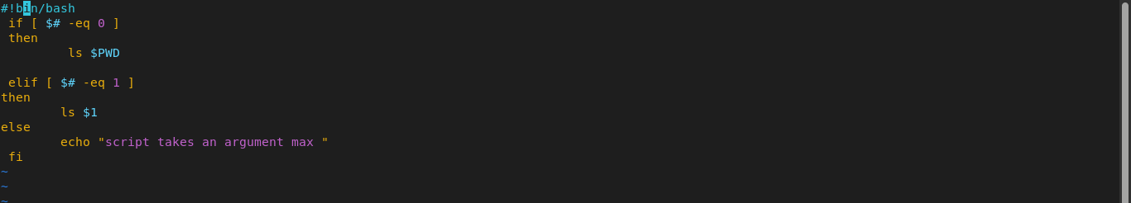

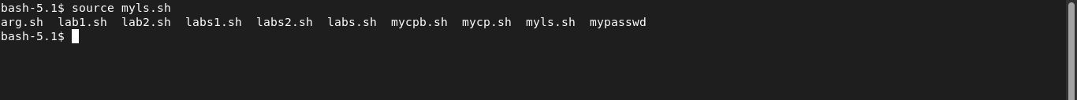

6.Enhance the above script to support the following options individually:

a.–l: list in long format
b.–a: list all entries including the hiding files.
c.–d: if an argument is a directory, list only its name
d.–i: print inode number
e.–R: recursively list subdirectories

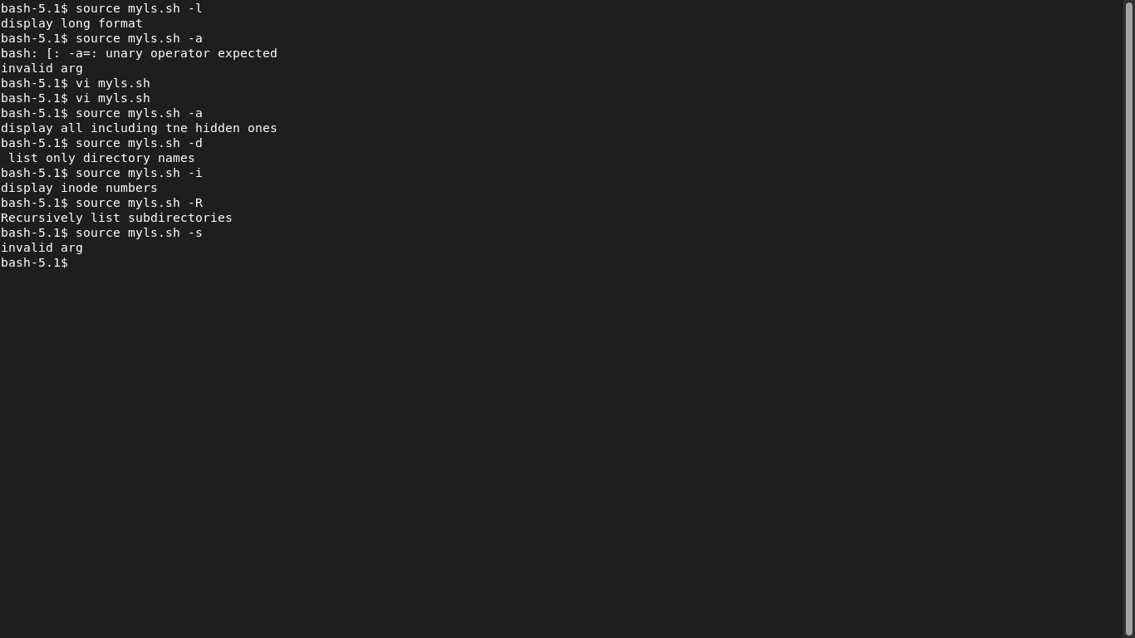
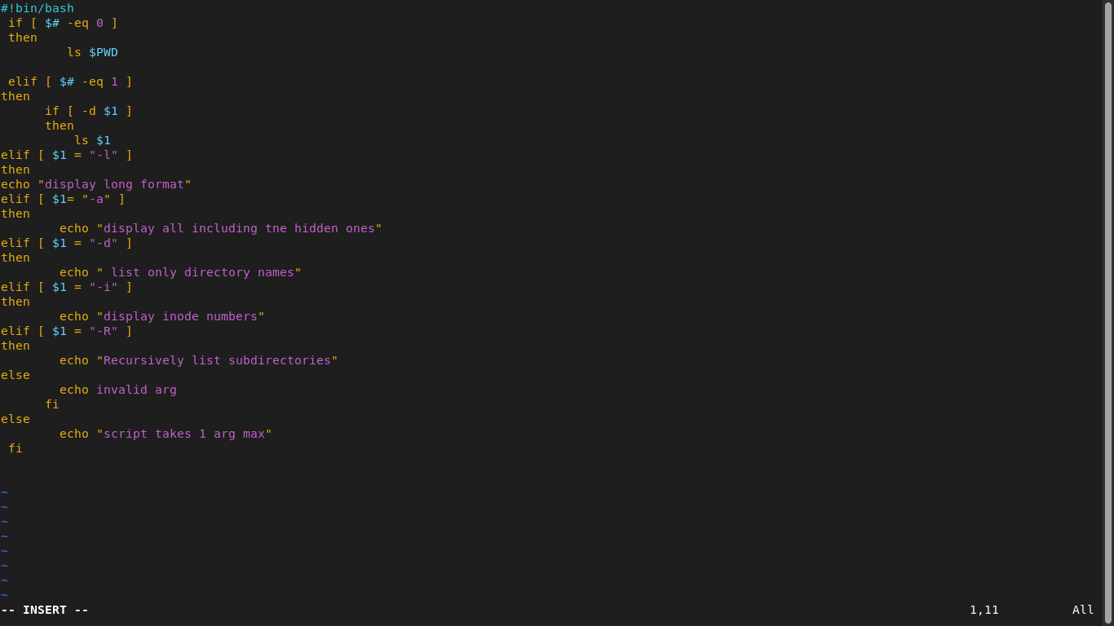
7. Create a script called mytest where:
a. It check the type of the given argument (file/directory)
b. It check the permissions of the given argument (read/write/execute)


8. Create a script called myinfo where:
a. It asks the user about his/her logname.
b. It print full info about files and directories in his/her home directory
c. Copy his/her files and directories as much as you can in /tmp directory.
d. Gets his current processes status



